**DATA SUBSETTING**

**Pre Requisite**

1) Make sure that you are connected to Data Source and Data target.

2) Create a Project with Data group, Data pool and Data set

In GT DataMaker click on the **target button**

You will be presented with the following screen.

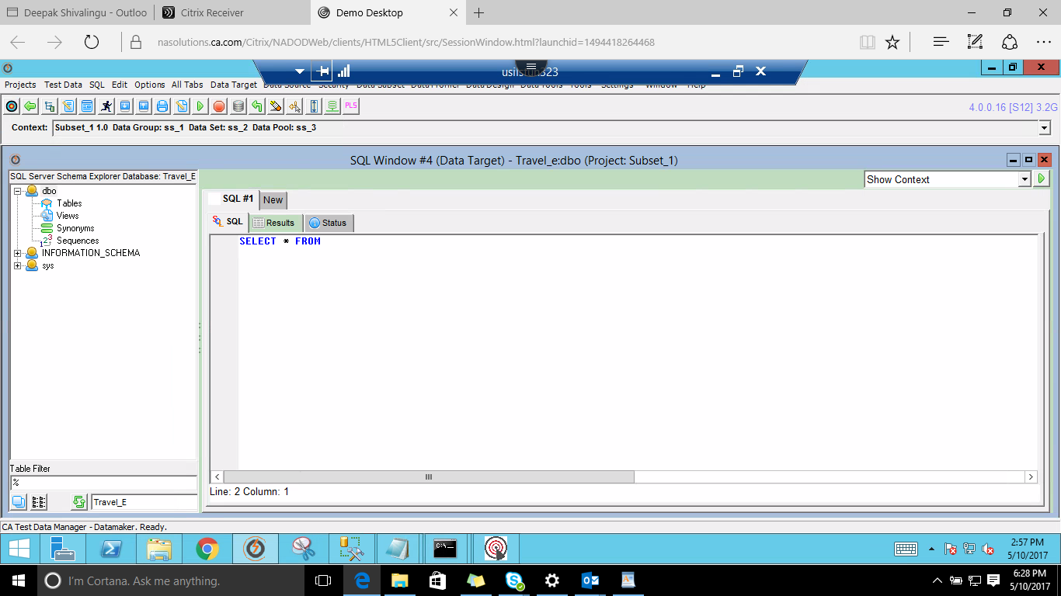

Right Click on the Table u will be presented with the below screen choose the option **'copy a set of 'TRUNCATE'** statements for the table

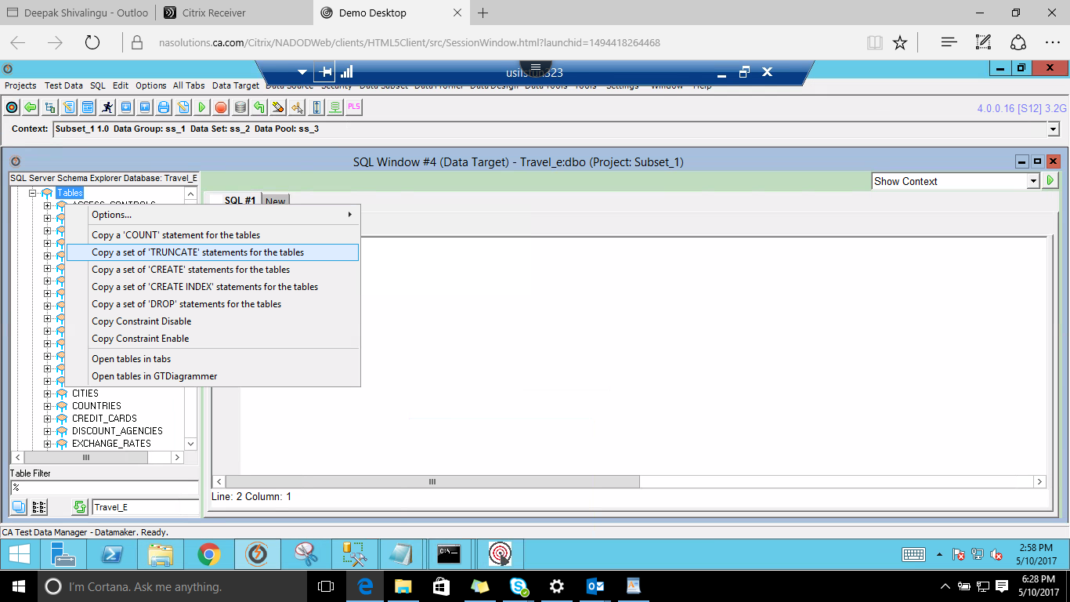

Paste the copied statements and run those statements by using **alt+a** key from your keyboard.

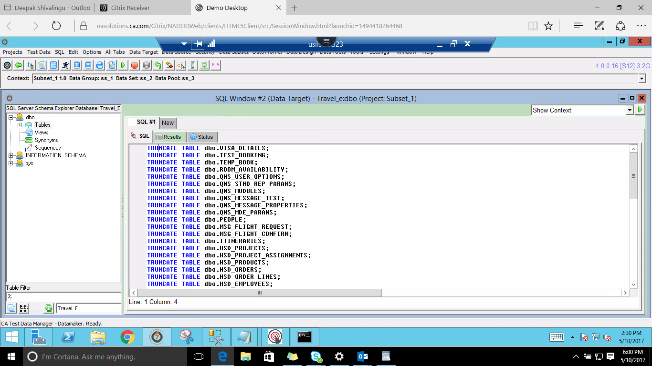

This will make sure that the there is empty database space.

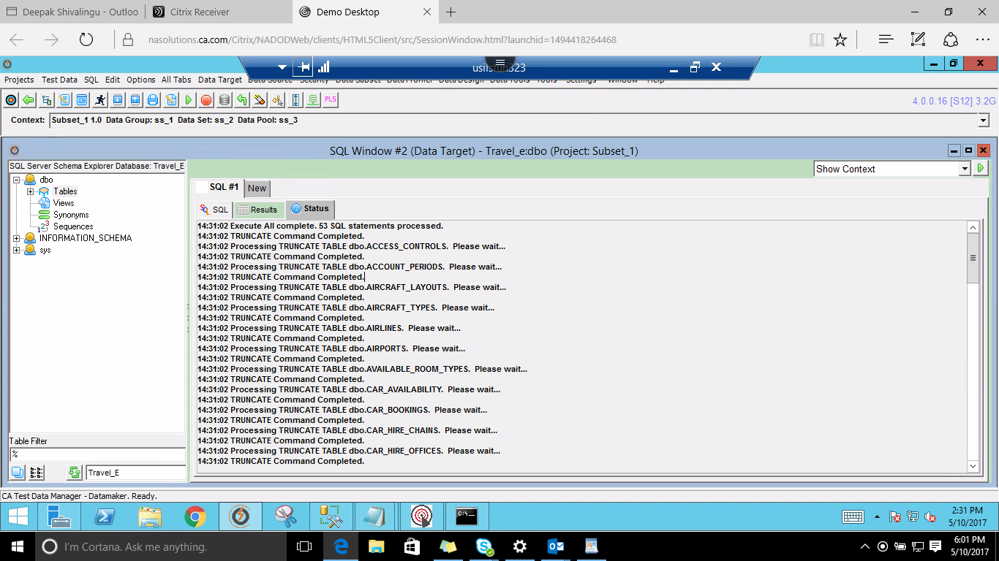

**OPEN GT SUBSET**

Connect to the repository by

Utilities --> Connect Repository.

Select the suitable repository or create a New Profile fill all the details and make sure the connection has access to repository tables else you will get an error message telling as shown below.

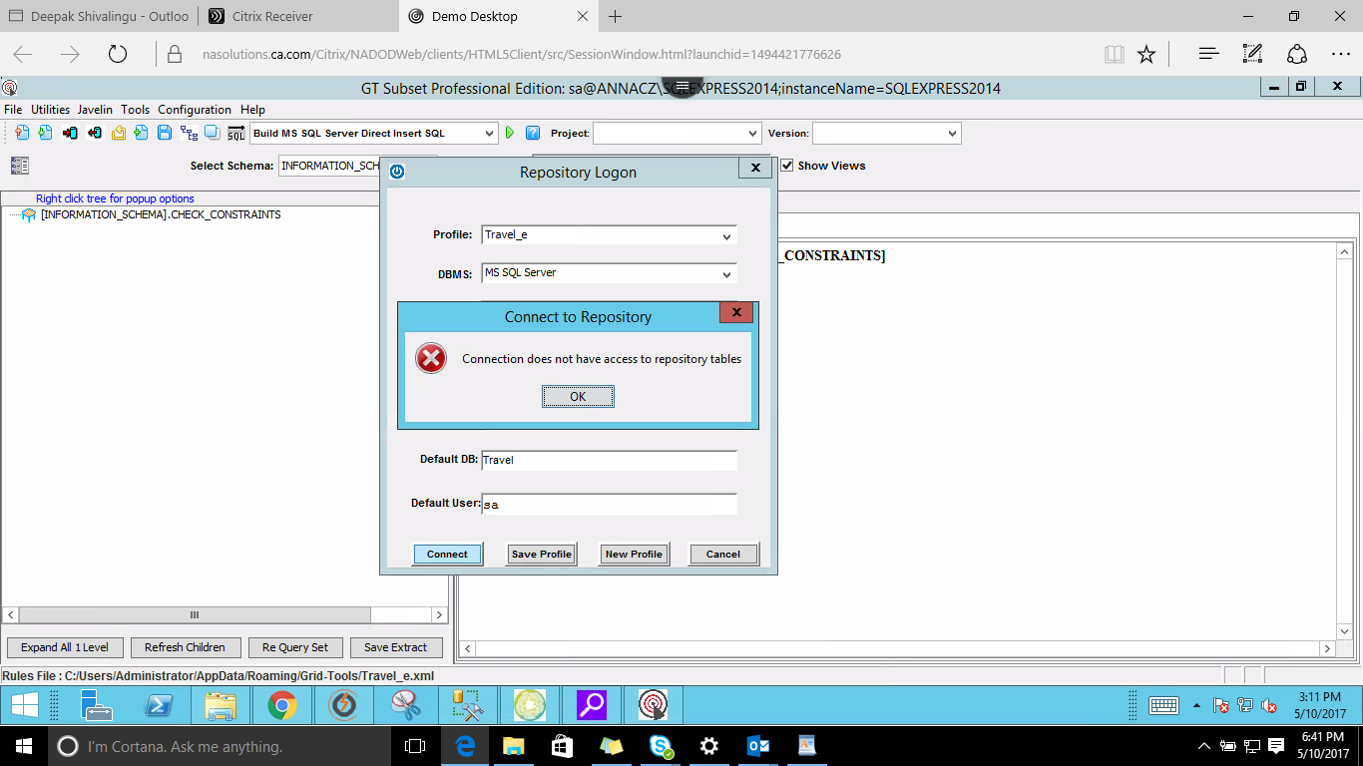

In this case we have chosen 'gtrep'

fill the details of the Repository Logon --> Connect

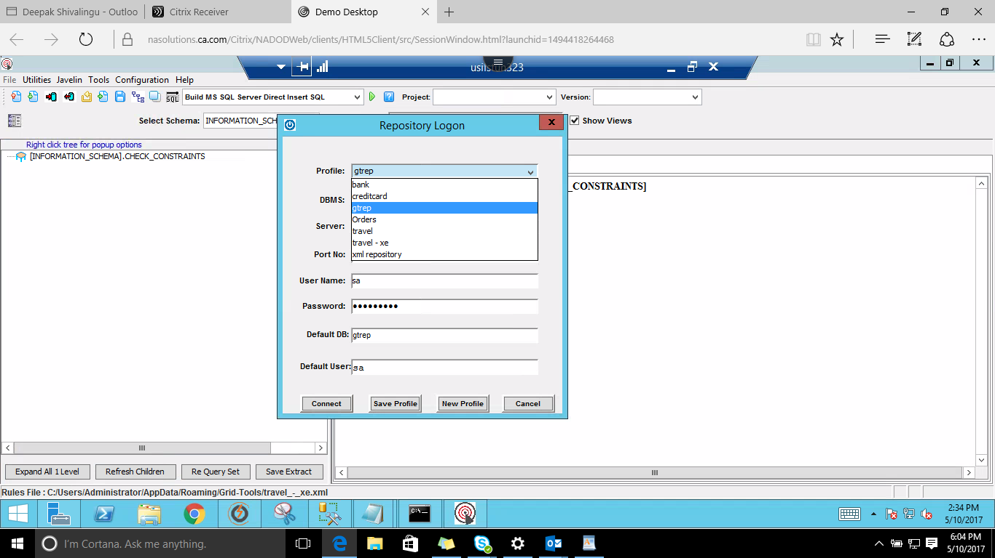

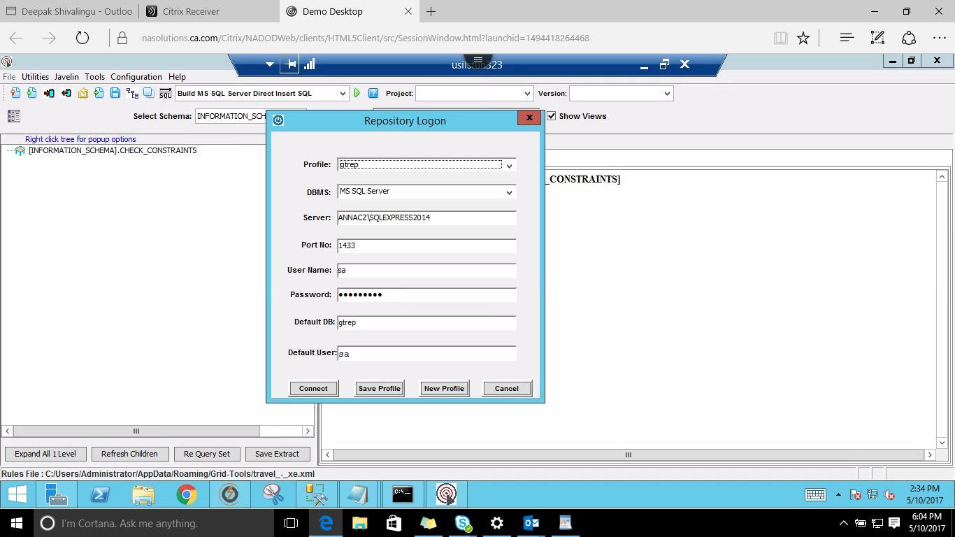

Make sure you save this extract to a Repository

for that go to

File --> Save Extract to Repository

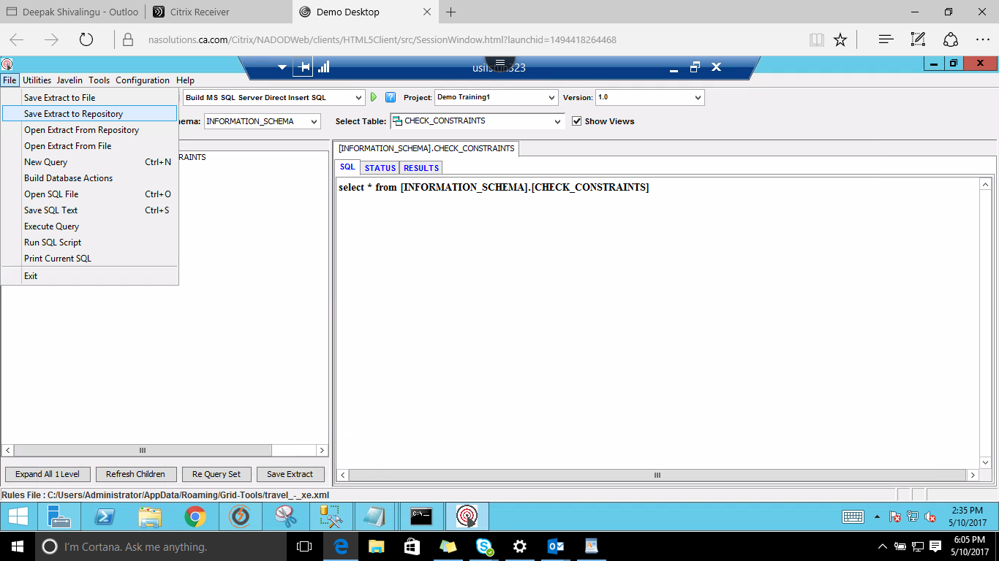

Fill the details --> Save

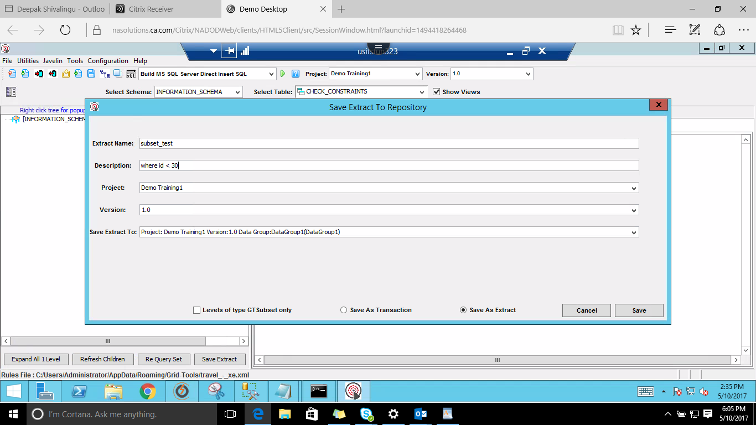

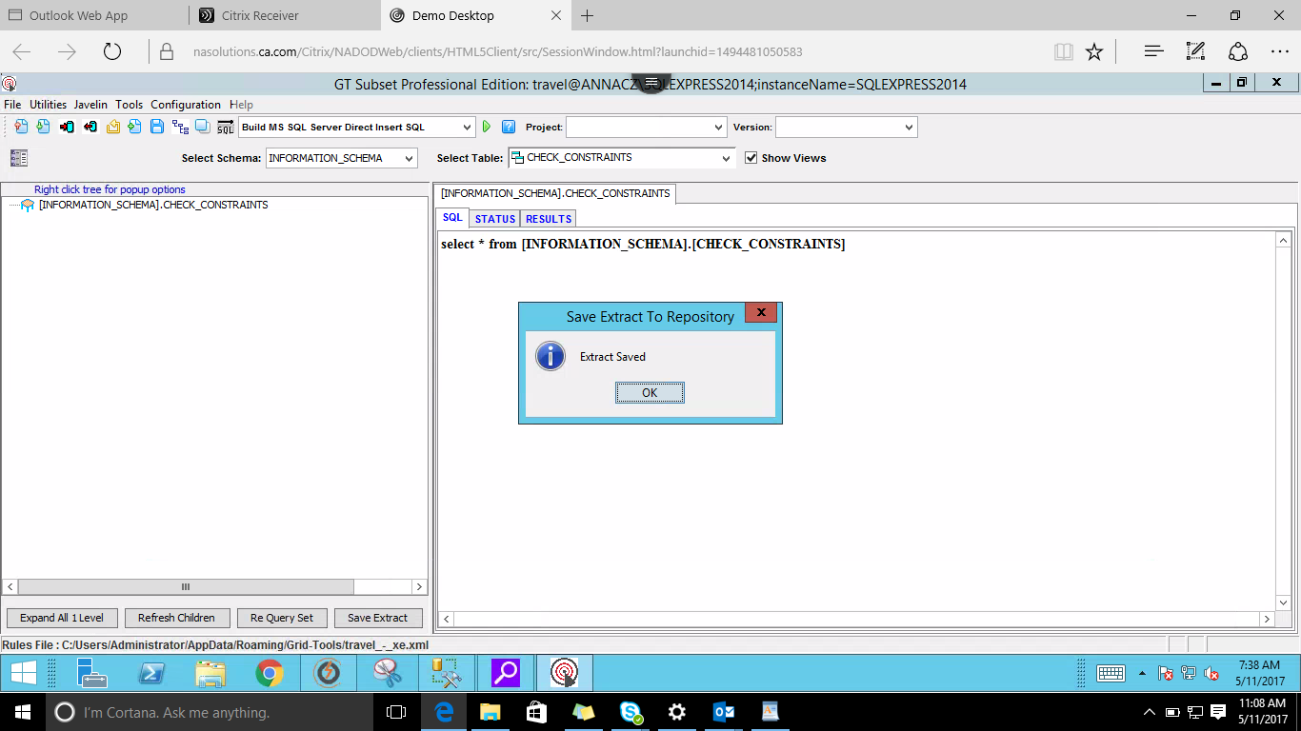

From the next 4 screenshots(SS) do the following

**SS a)** Select Build MS SQL server from Export/Import.

**SS b)**Project --> Current project you are working on.

**SS c)** Select Schema --> dbo

**SS d)** Select Table --> choose the table which you are working on, here we are choosing PEOPLE table

**SS a)** Select Build MS SQL server from Export/Import.

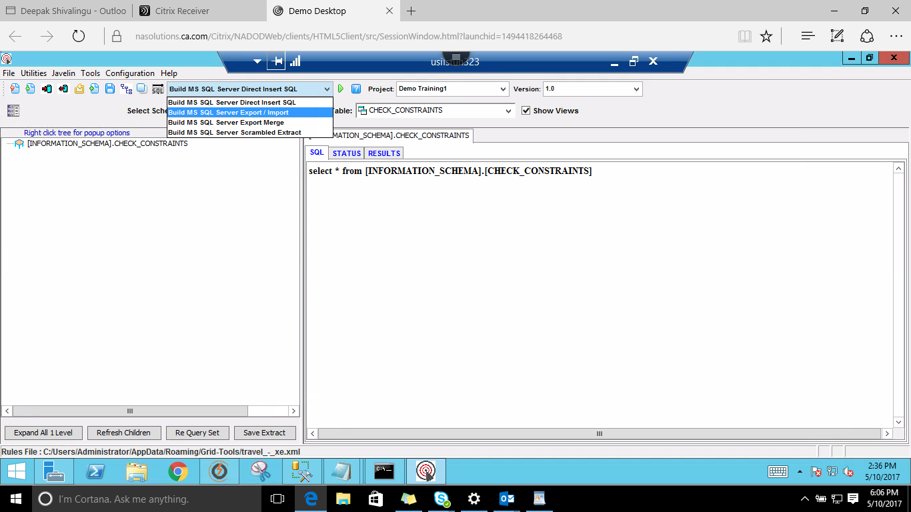

**SS b)**Project --> Current project you are working on.

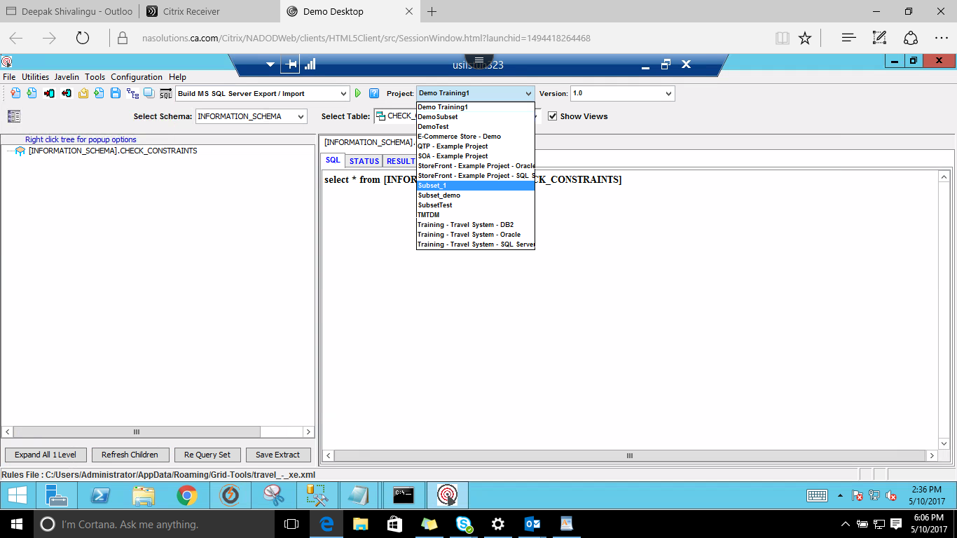

**SS c)** Select Schema --> dbo

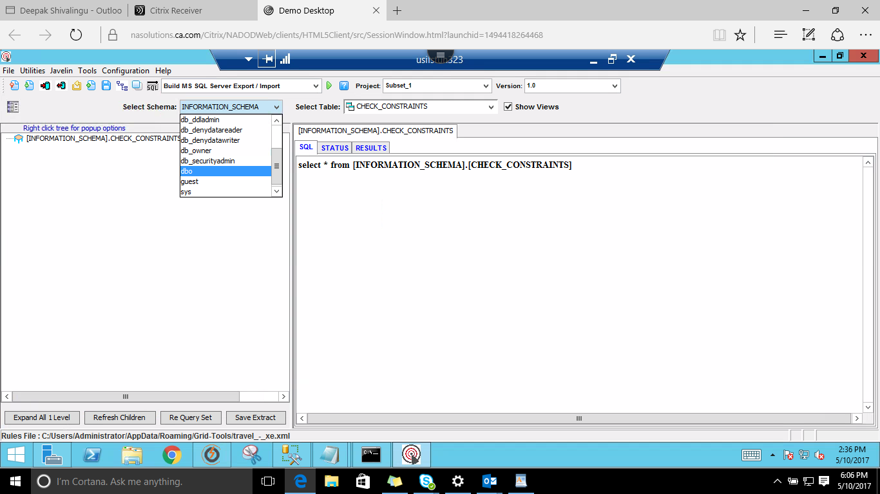

**SS d)** Select Table --> choose the table which you are working on, here we are choosing PEOPLE table

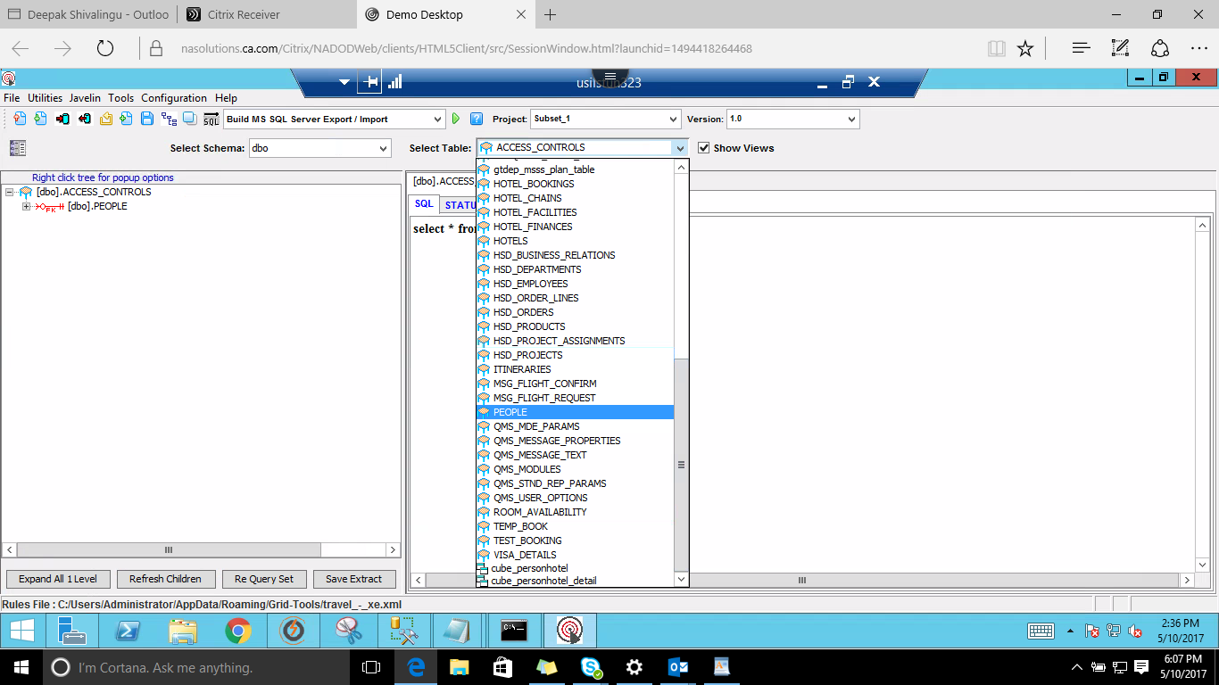

Once the above steps are executed you will be presented with a screen as shown below.

Next

Remove Relationships for managing data hierarchy by

Right click on PEOPLE --> Remove 'Red Relationships' this is to mainatin a certain hierarchy in the table order

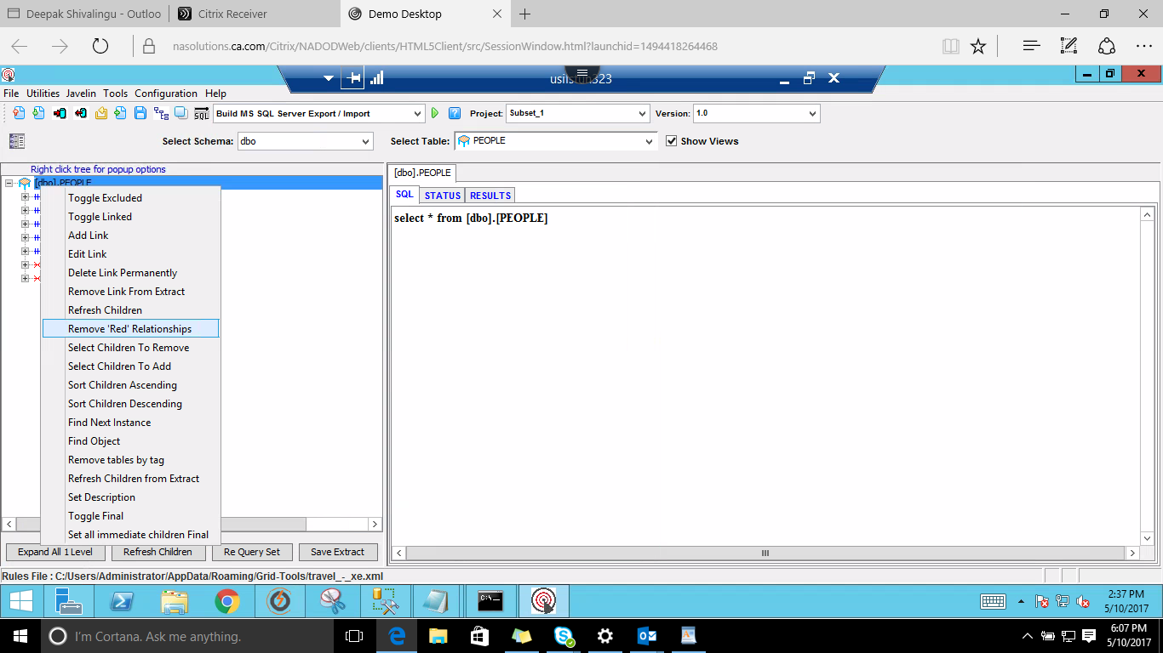

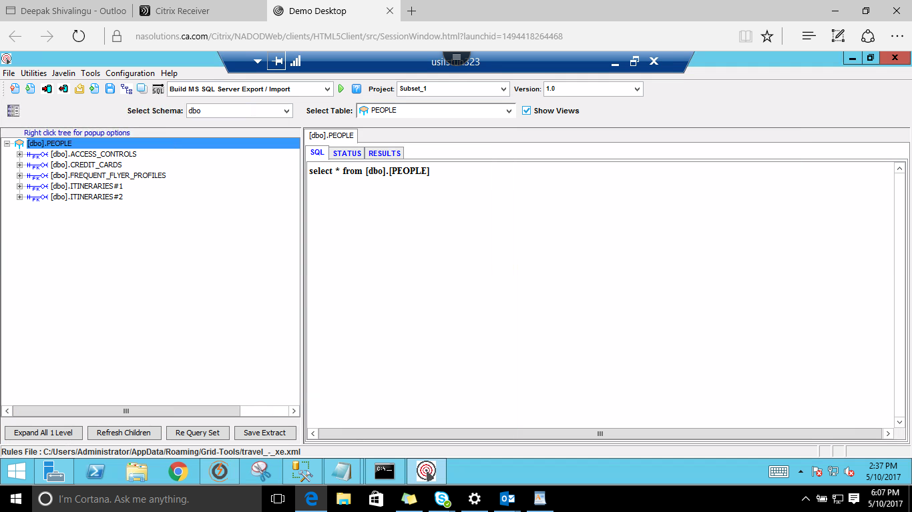

If you want to get a particular data according to the requirement write a SQL query for the requirement accordingly.

here SQL query which we have used is to get ids < 30 as shown below.

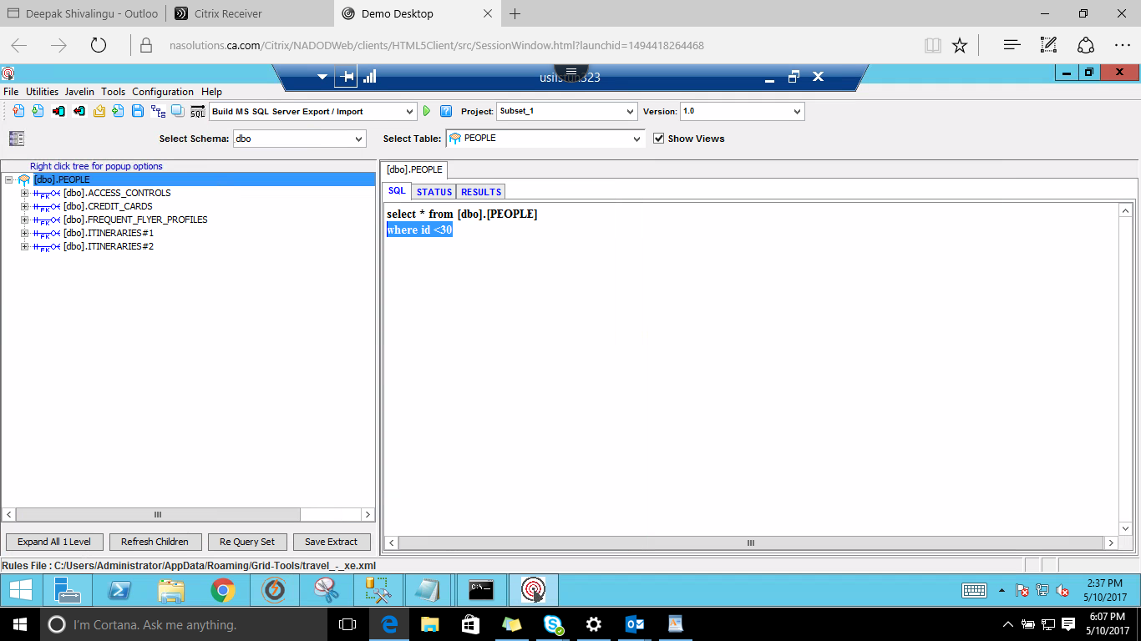

Execute the SQL statement by clicking the SQL button(below help)and see how many rows you retrieve for the query as shown below.

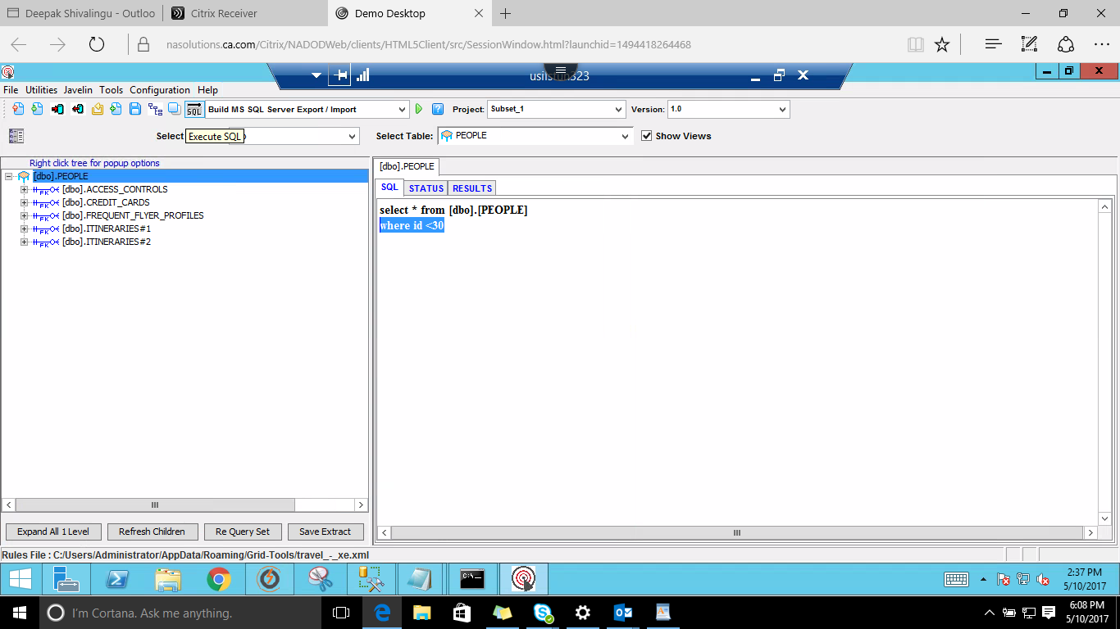

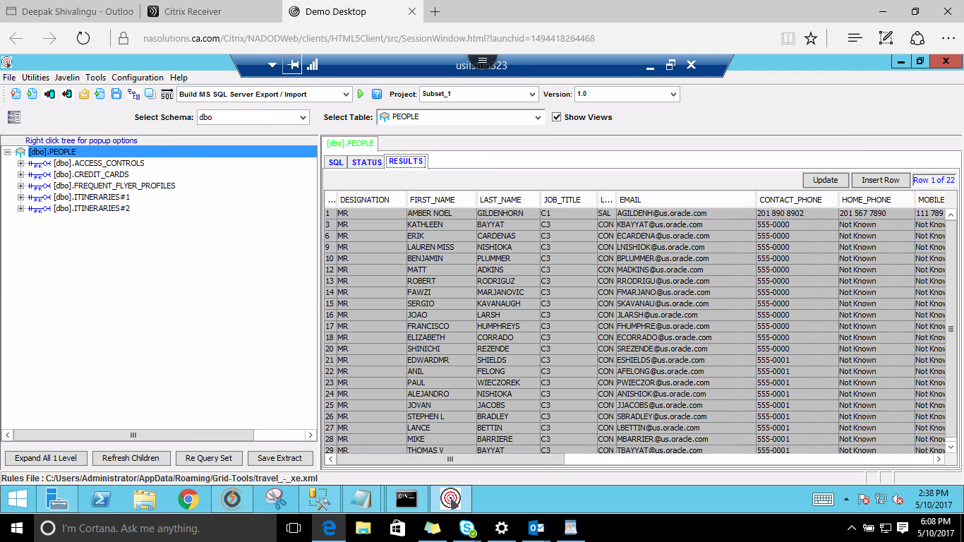

Next click on the 'Database Actions' Button.

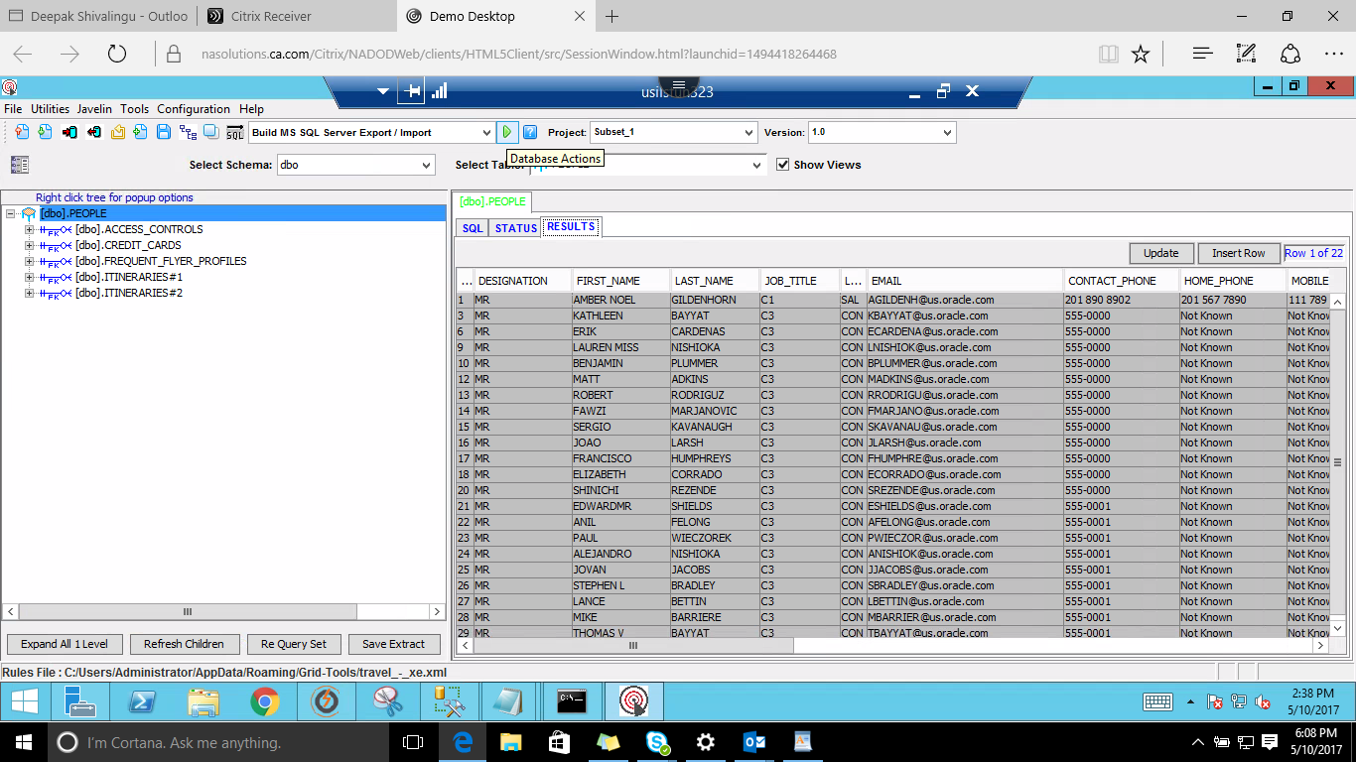

Give the action name, and Navigate to Extract Table

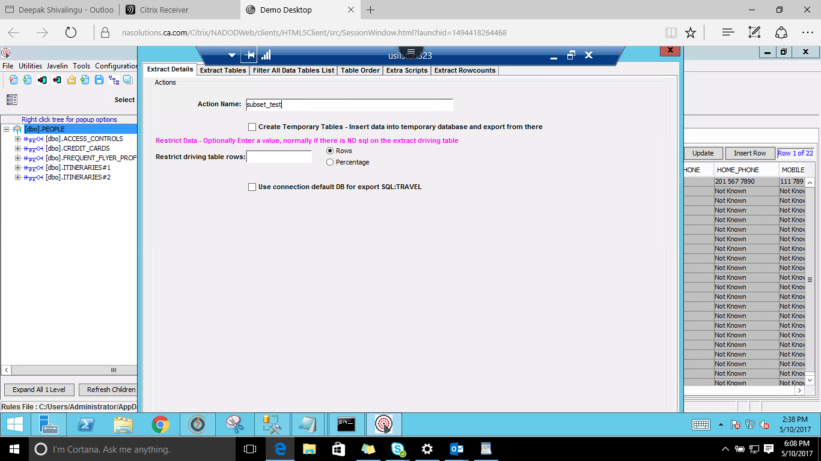

The Extract you have saved earlier will be automatically checked in or else select the extract by checking the check box of the saved extract.

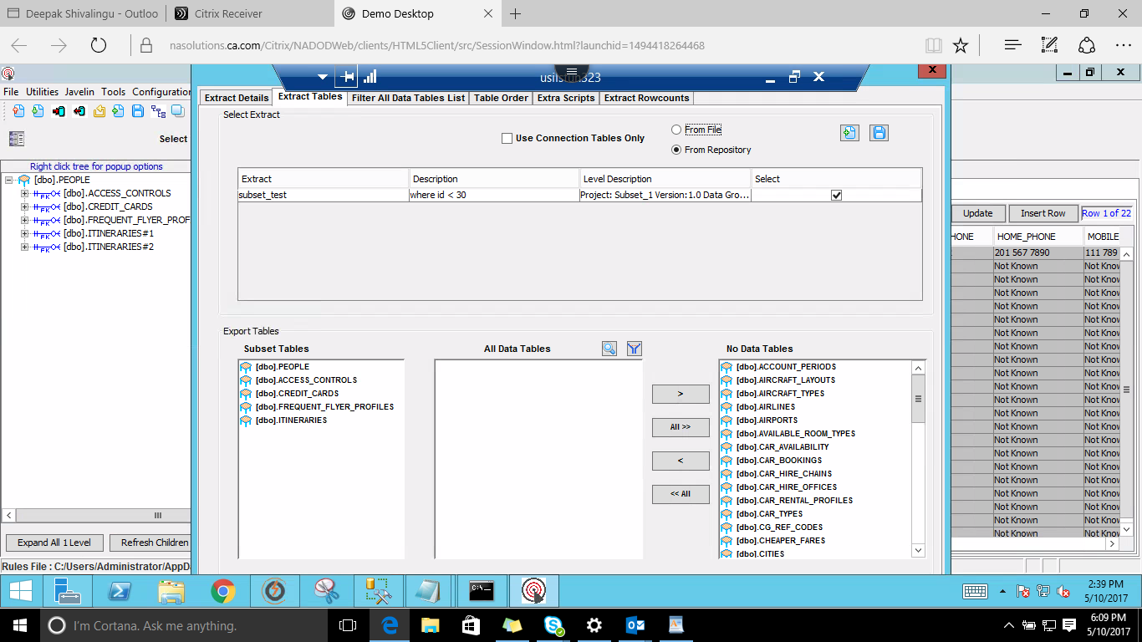

Choose the data tables which are required.

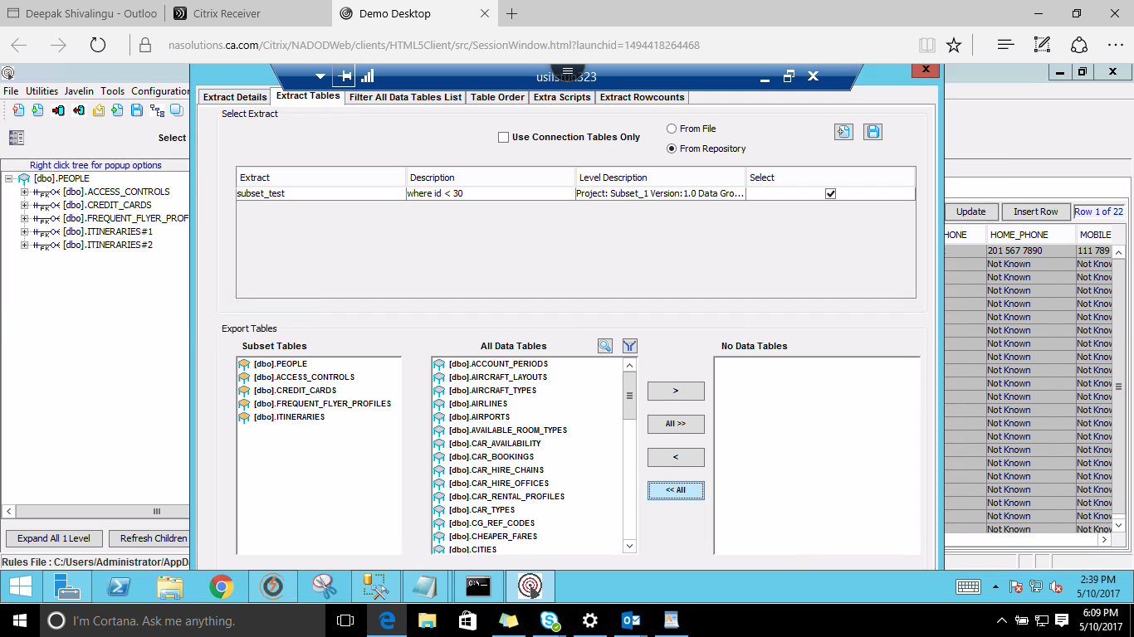

Click on Generate

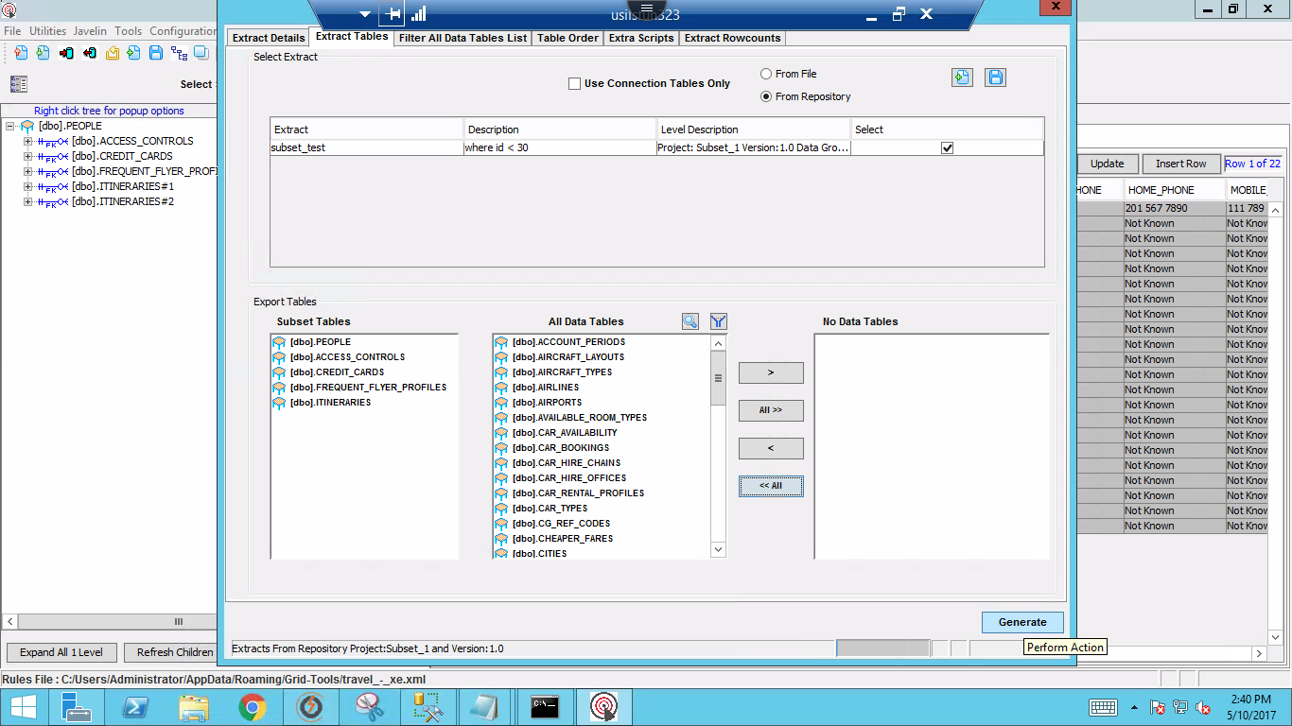

Once you Click on Generate the following 3 files with will be generated

1. 'Subsetname'_Export.bat
2. 'Subsetname'_import.bat
3. 'Subsetname'_preview.sql

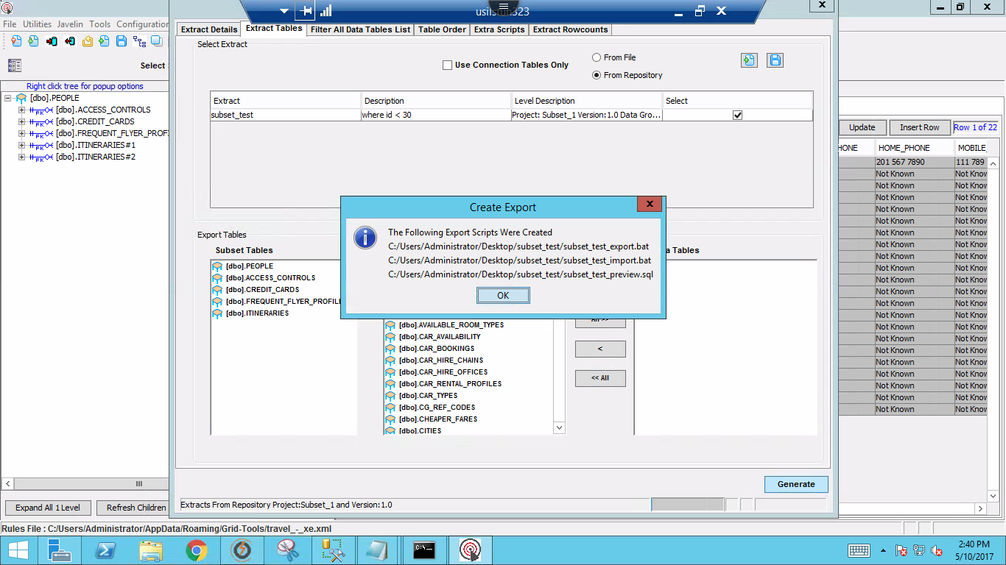

Go to the specific location where you have generated the 3 files then

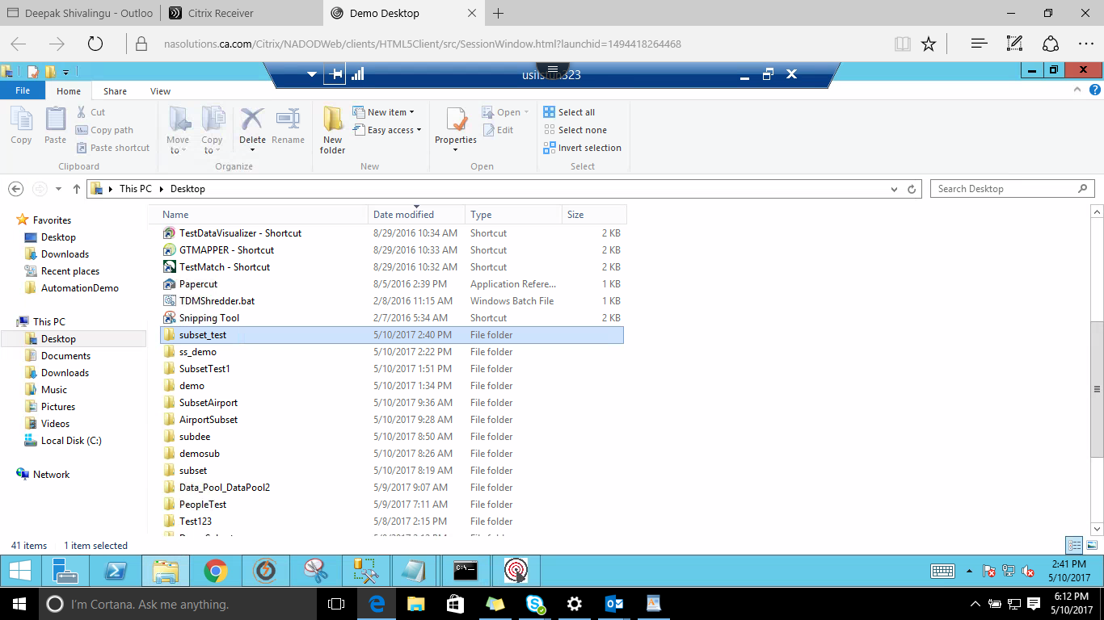

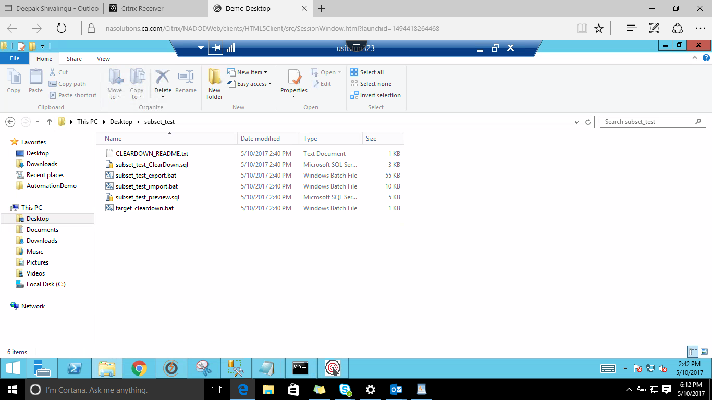

Hold Shift+Right Click Mouse --> open the Command Promt so that the command prompt is in the same directory where the 3 files are.

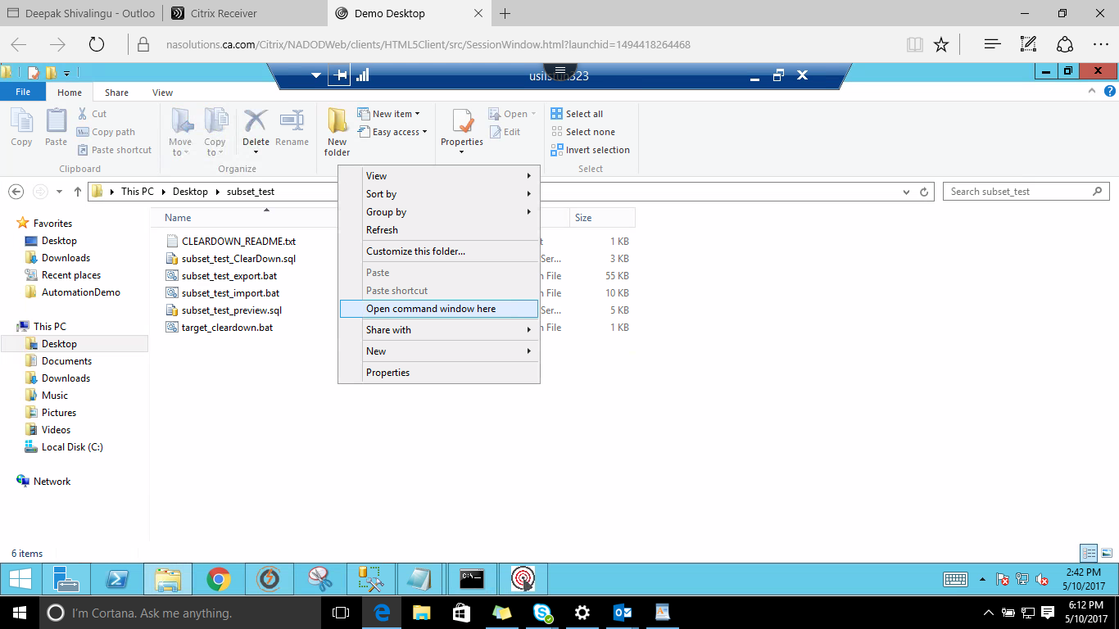

Execute the export.bat file by giving the username password of the server and the server name as shown below

here the command executed is subset_test_export.bat sa Gridt00ls ANNACZ\SQLEXPRESS2014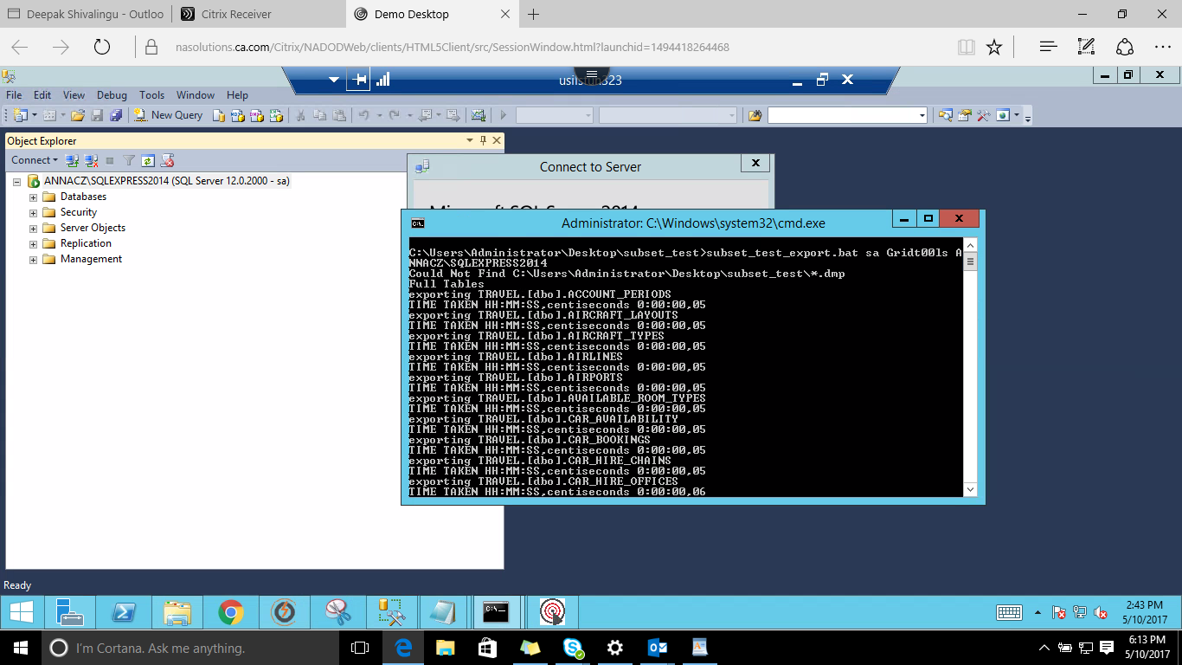

once the command is executed you will be landed with the below screenshot.

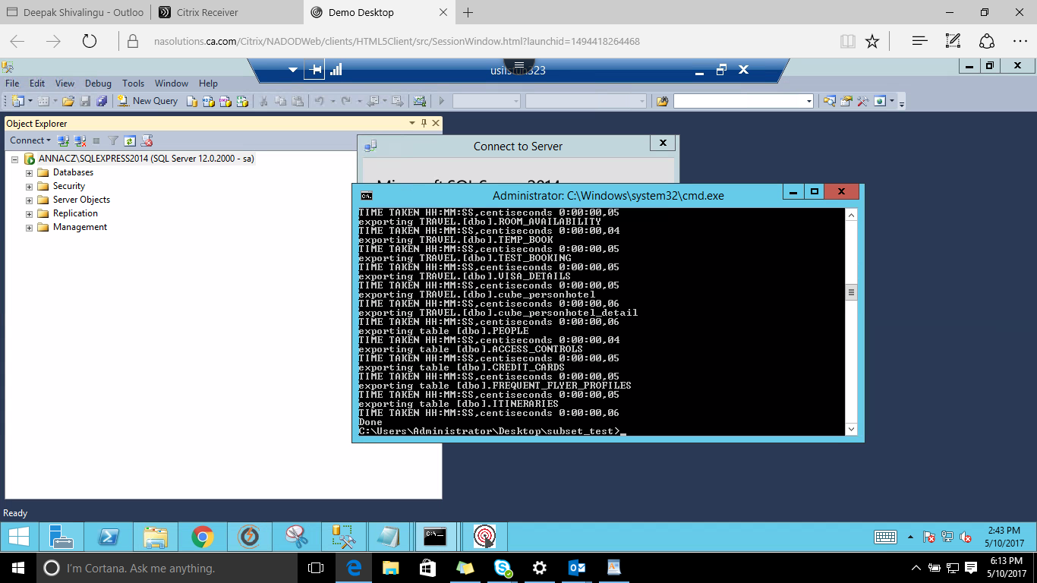

After exporting we have to import the Files to the **target** this is done by executing the import.bat file as shown below

here the command executed is subset_test_import.bat sa Gridt00ls ANNACZ\SQLEXPRESS2014 TRAVEL_EX

where **TRAVEL_EX** is the **Target Name**

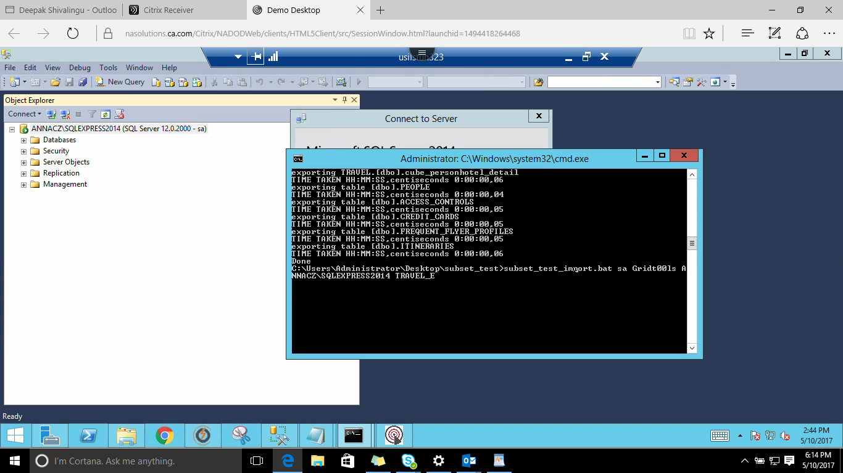

After Executing the rows will be Imported.

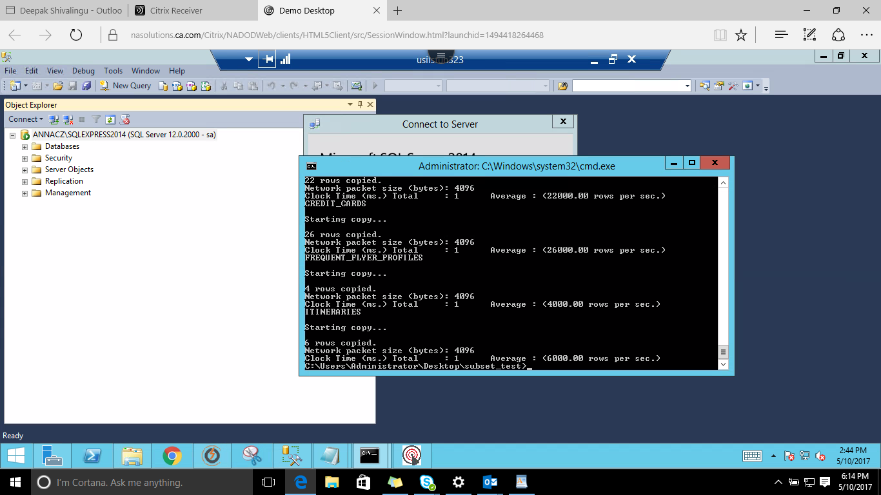

You can Verify the same by going to Data Subset and Click on the Preview SQL button and click on RUN

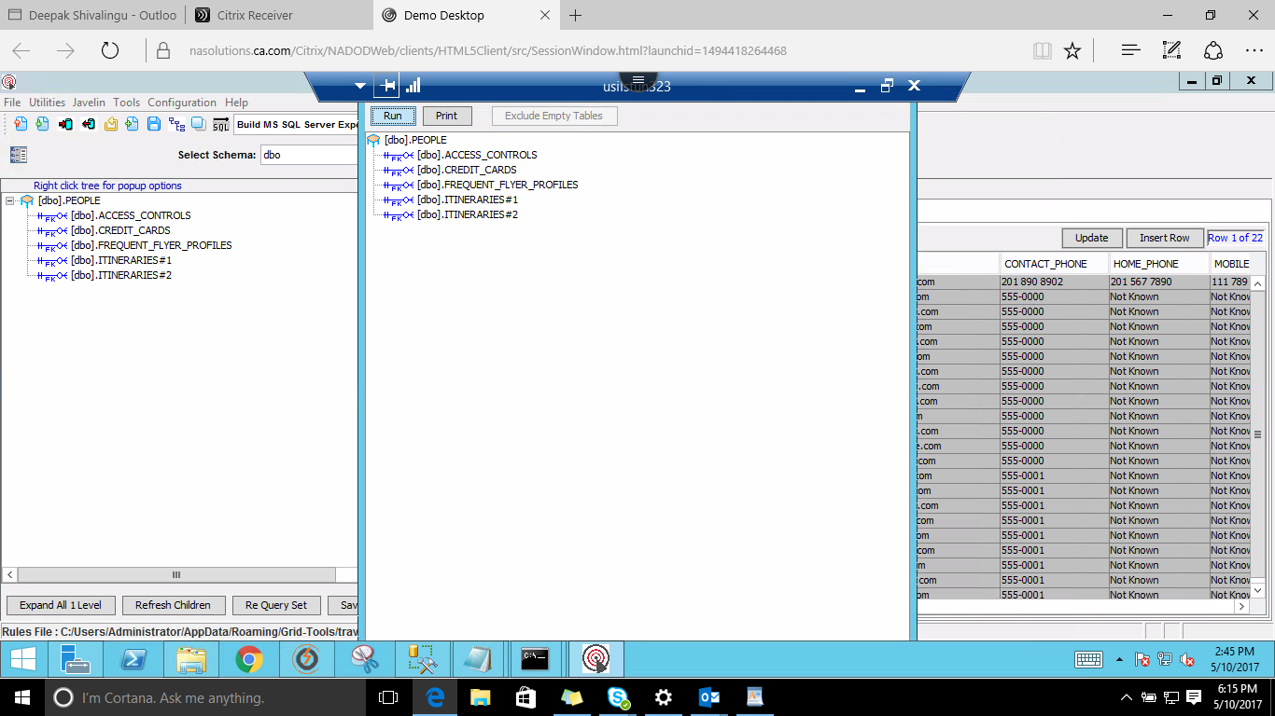

The Number of Rows which are imported will be displayed.

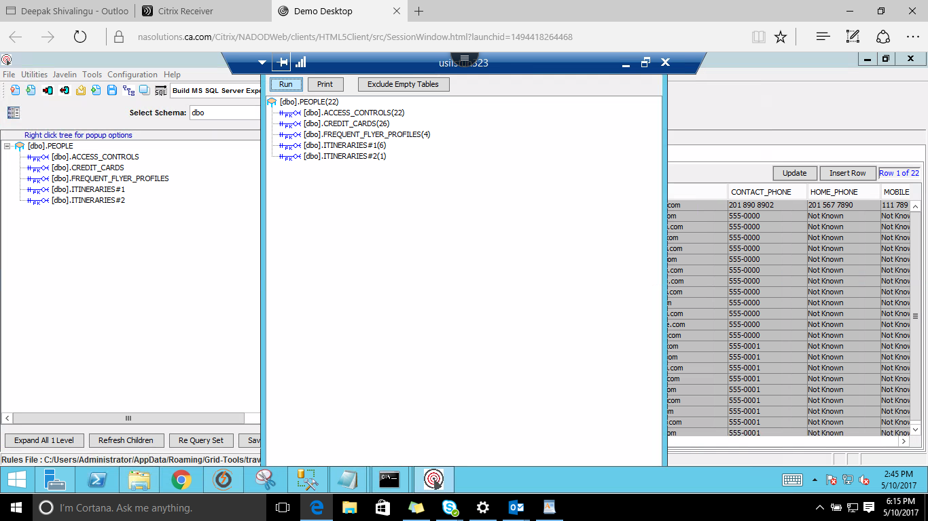

from the tables run a SQL query to fetch the rows

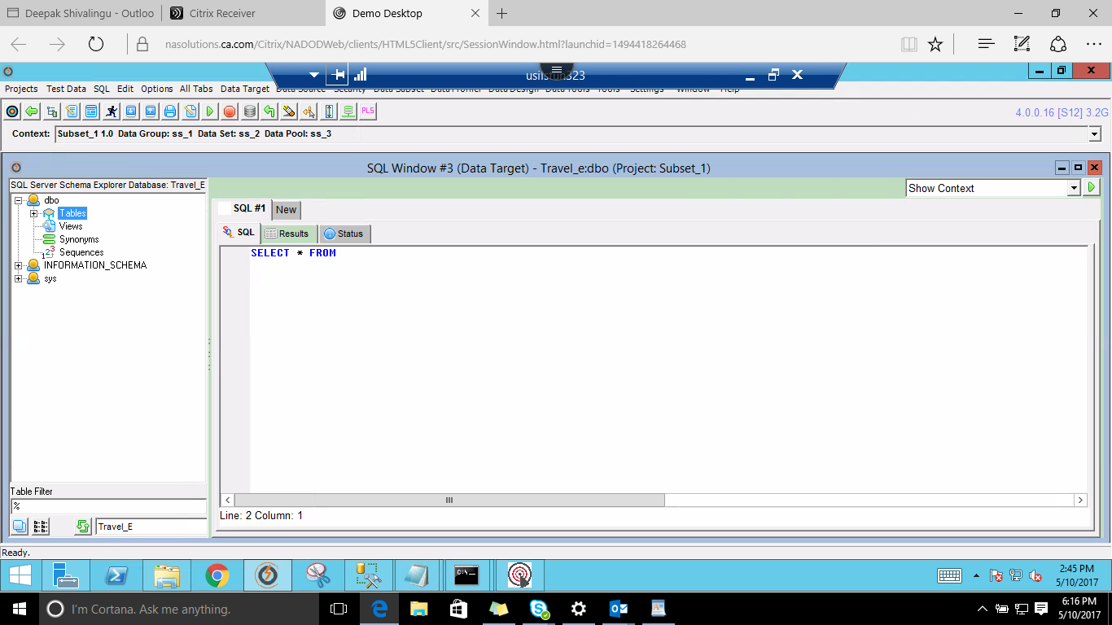

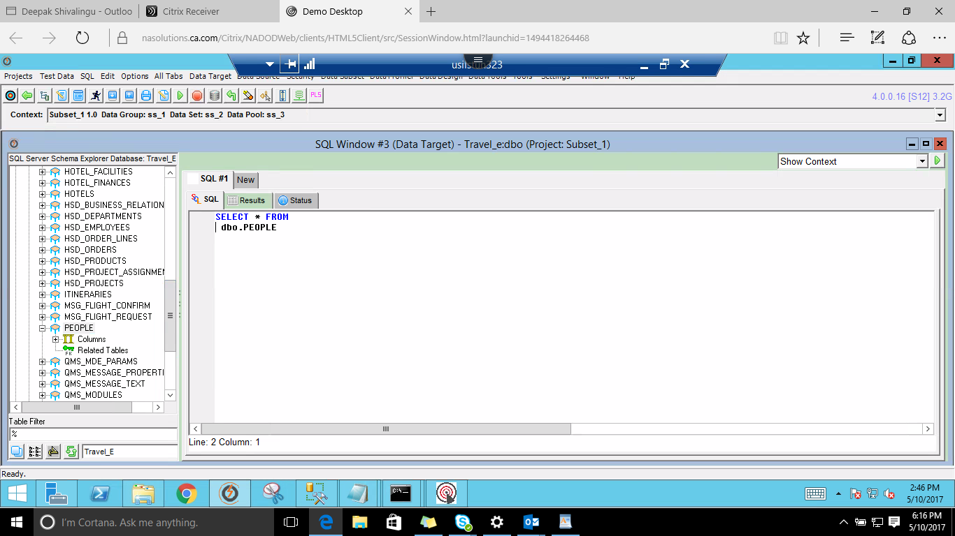

The number of rows fetched is shown as below.

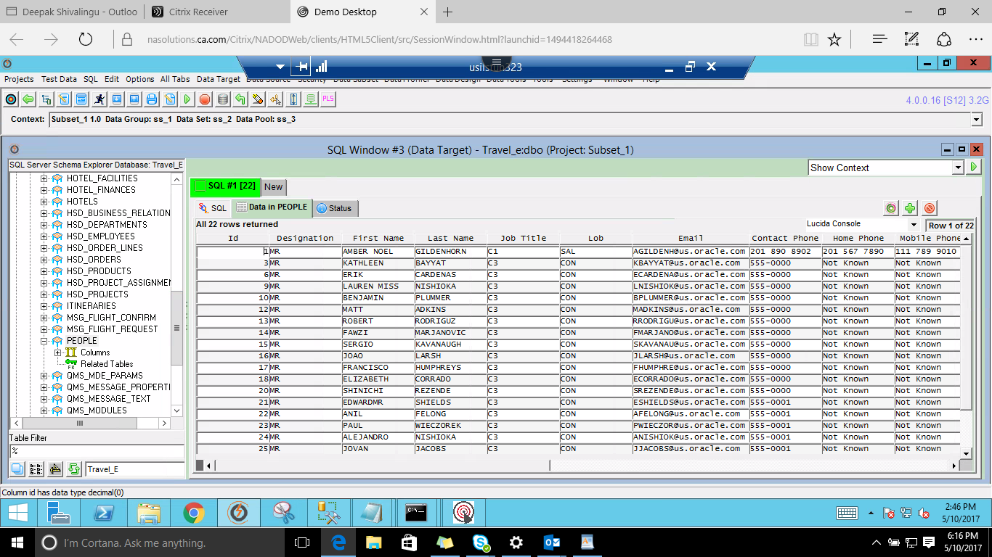

--------------------------------------------------------XX--------------------------------------------------------